Man-in-the-Middle Attack Simulation and Defense Mechanisms

Introduction To Cryptography - H1



Submitted To:
Annas Waseem Malik

Submitted by:
Student Reg# | Student Name
L1F22BSCS0364 | Muhammad Yaqoob
L1F22BSCS0382 | Sehrish Naseer

Faculty of Information Technology & Computer Science

University of Central Punjab

Table of Contents:

Man-in-the-Middle Attack Simulation and Defense Mechanisms Using Linux Network Namespaces and Traffic Shaping 3
I. Introduction 3
II. Literature Review 4
III. Threat Model 4
IV. Methodology 5
A. Designs of Topology 5
B. Traffic Shaping and Interception 6
V. Implementation 6
A. Routing Configuration 6
B. Attack Simulation Scripts 7
VI. Simulation Design (NS-3) 7
A. Simulation Topology 7
B. Simulated Conditions 8
In order to establish each network condition, a netem qdisc is attached to the attacker interface, its impact is measured by the victims, and it is removed before the next is applied. The circumstances listed below were replicated: 8
C. Measurement and Analysis 8
VII. Results and Analysis 8
A. Parameter Metrics Table 8
B. Performance Metrics Table 9
VIII. Defense Mechanisms 11
IX. Discussion and Limitations 12
X. Conclusion 12
XI. Implementation Repository 12
XII. References 13

Man-in-the-Middle Attack Simulation and Defense Mechanisms Using Linux Network Namespaces and Traffic Shaping
Abstract
Man-in-the-Middle (MITM) attacks continue to pose a danger to network integrity, especially as wireless and Internet of Things devices proliferate and provide high-latency and loss-prone communication pathways. Using Linux Network Namespaces and Traffic Control (tc) to simulate wireless channel deterioration, this study offers a controlled, repeatable environment for testing MITM assaults. We assess the effects of delay injection, packet loss, and bandwidth limiting on TCP and UDP traffic by placing an attacker node directly in the forwarding channel between two victims. Our findings show that whereas UDP retains stronger persistence at the expense of noticeably increased jitter, TCP performance is disproportionately impacted by injected loss caused by congestion window resets. Additionally, we evaluate the efficacy of defensive techniques, showing that whereas mutual authentication (mTLS) and TLS 1.3 safeguard the data plane, they do not lessen the availability implications of on-path manipulation. We offer a GitHub repository with full implementation scripts.
Keywords—Cybersecurity, Man-in-the-Middle, Network Namespaces, Traffic Shaping, Wireless Security, Network Performance.

I. Introduction
The attack surface for interception-based threats has been greatly increased by the movement of network topologies toward decentralized, edge-centric, and wireless-dependent systems. The Man-in-the-Middle (MITM) attack, which involves an attacker intercepting, monitoring, or altering traffic between two legal nodes, is one of these fundamental yet crucial vulnerabilities. Large-scale experimentation and reproducibility are made more difficult by traditional research's frequent reliance on resource-intensive Virtual Machines (VMs) or physical hardware.
In order to overcome these difficulties, this article designs a "Wireless-Like" MITM environment using Linux Network Namespaces, a lightweight virtualization feature. We emulate the unpredictable characteristics of wireless settings, such bursty packet loss and fluctuating propagation delays, by integrating the Linux Traffic Control (tc) subsystem with netem.
Our main goals are to measure the degradation of communication quality caused by on-path attackers and assess the durability of current network-layer and cryptographic countermeasures. Our investigation is organized around four research questions:
- RQ1: How may an on-path attacker affect target nodes' end-to-end performance metrics?
- RQ2: How much do delay, packet loss, and bandwidth limitations affect various kinds of traffic?
- RQ3: Which particular defenses successfully lessen the effects of MITM manipulation?
- RQ4: Under unfavorable threat conditions, how do transport-layer protocols (TCP vs. UDP) differ in performance?

II. Literature Review
The relationship between cybersecurity measurements and simulation has been the subject of more recent research. In time-sensitive IoT systems, where even a 50ms delay might break control loops, Alodat (2021) showed that MITM attacks cause a typical deterioration in network operation [7]. Wilson (2025) evaluated IoMT (Internet of Medical Things) resilience using NS-3 and discovered that MITM events cause a mean packet loss of 11.5%, which is consistent with our namespace-specific evidence [2].
Simulation methods have also changed. The significance of "faithful simulation"—in which the environment exactly replicates the networking stack of the Linux kernel—is emphasized by Serena et al. (2025) [8].
By use native kernel namespaces instead of abstract models, our method embodies this idea. Possemato and Fratantonio (2020) draw attention to the ongoing weaknesses in HTTPS/TLS configurations on mobile platforms, pointing out that although the protocol is reliable, coding-level errors (such as bypassing certificate errors) continue to be the main means of successful MITM interception [5]. By assessing mutual TLS (mTLS) and certified attachment in a shaped network environment, our study expands on this.

III. Threat Model
Our threat model is predicated on a "On-Path" attacker, also known as a "BUMP-IN-THE-STACK" or "Transparent Gateway." The following abilities are possessed by the attacker:
- Interception: The ability to view every raw frame that travels between Victims 1 and 2.
- Manipulation: The capacity to alter, delay, or reject packets in accordance with preset protocol headers or rates.
- Limiting: Managing the forwarding ports' egress bandwidth.
- Security: Unless Deep Packet Inspection (DPI) or timing analysis is used, the attacker functions as a router at Layer 3, making it impossible to differentiate from a genuine gateway.
The experiment focuses on performance loss and avoiding unauthenticated flows because the attacker does not originally have the private keys for the victims' interaction.
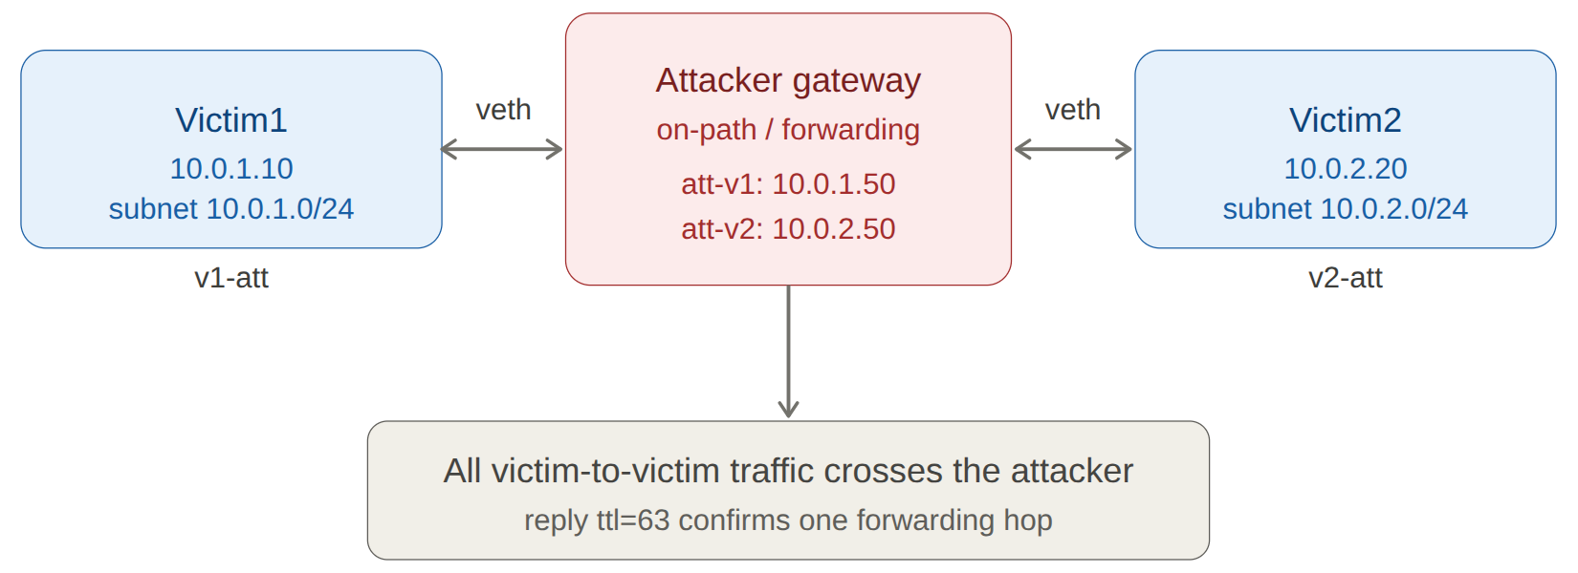
Figure 1: Overall Network Topology

IV. Methodology
Linux Network Namespaces are used to build a three-node routed architecture in the study technique. This method preserves the functionality of common Linux tools like iptables, tcpdump, and iproute2 while guaranteeing total isolation of the networking layers.

A. Designs of Topology
The surroundings include:
- Victim1 (V1): A client or Internet of Things sensor is represented by the source node (10.0.1.10).
- The gateway node (10.0.1.50, 10.0.2.50) with IP forwarding enabled is the attacker (A).
- Victim2 (V2): A server or controller is represented by the destination node (10.0.2.20).
By setting the default gateways in the victim namespaces to refer to the Attacker's interfaces, interaction among V1 and V2 is pushed through the Attacker node.

B. Traffic Shaping and Interception
The Attacker's outgoing interfaces are used to mimic wireless channel properties using tc qdisc and the netem (Network Emulator) scheduler. This enables the accurate injection of:
- Transmission and queuing delays are simulated using fixed and variable latency.
- Using the Bernoulli model for separate losses is known as probabilistic packet loss.
- Token Bucket Filter (TBF) is used to restrict throughput due to bandwidth constraints.

V. Implementation
A host running Ubuntu 26.04 is used to carry out the task. The namespaces and forwarding path are created using the shell-based logic that follows.
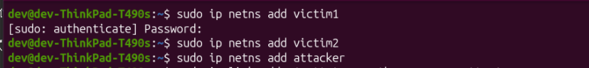
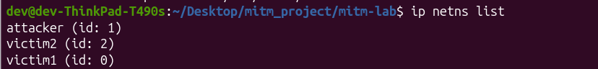
Figure 2: Namespace Creation Commands

A. Routing Configuration
Net.ipv4.ip_forward is activated in the Attacker's namespace to guarantee that the Attacker node serves as the center.
# Enable IP Forwarding on Attacker
ip netns exec Attacker sysctl -w net.ipv4.ip_forward=1

# Add Routes on Victims
ip netns exec Victim1 ip route add default via 10.0.1.50
ip netns exec Victim2 ip route add default via 10.0.2.50

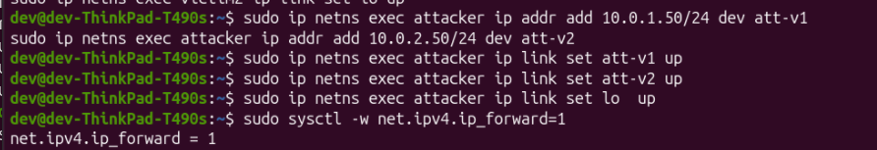 Figure 3: Routing Configuration
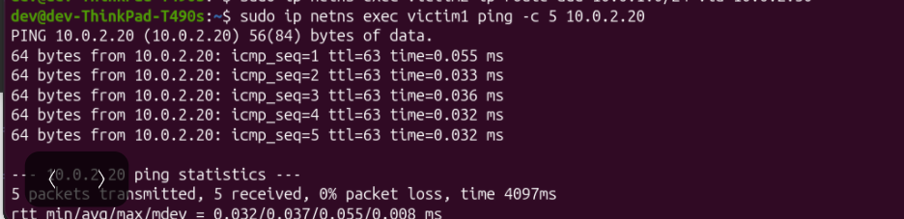 Figure 4: Successful Ping Test

B. Attack Simulation Scripts
The tc command is used to initiate certain scenarios. To simulate a 80 ms delay with 5% loss, corrupt 1%, duplicate 1%, for example:
sudo ip netns exec attacker tc qdisc add dev att-v2 root netem delay 80ms 20ms loss 5% corrupt 1% duplicate 1%

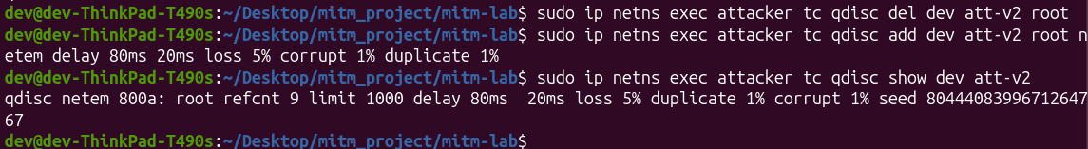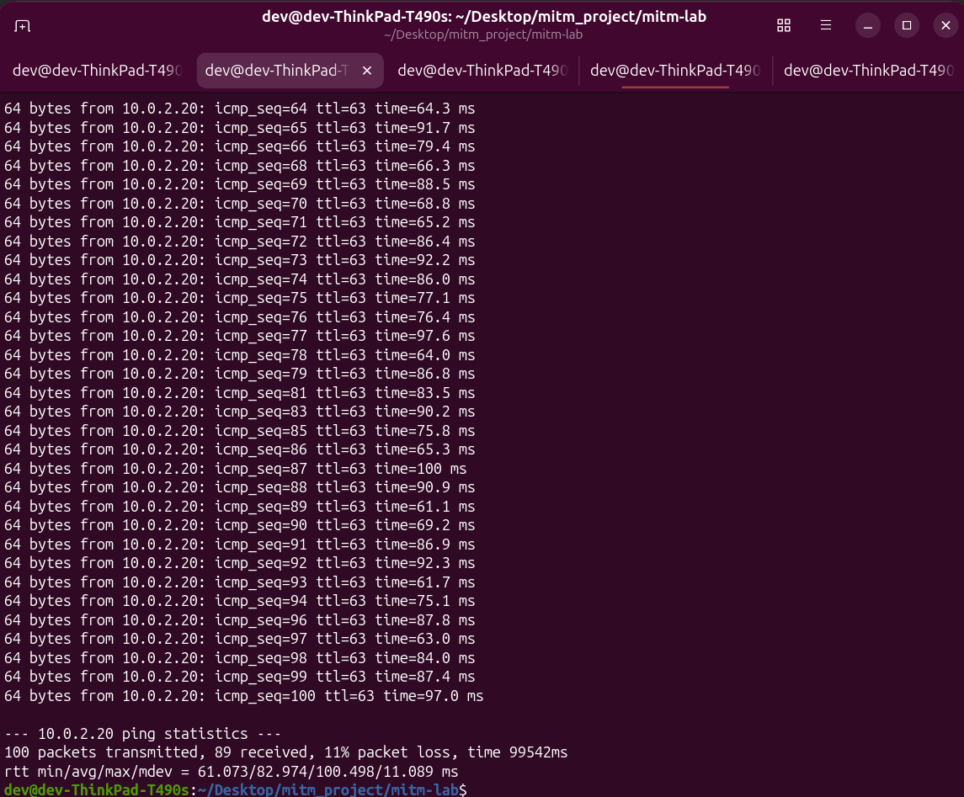Figure 5: Effects Simulation

VI. Simulation Design
The network delays in this work were recreated using the Linux Traffic Control (tc) subsystem with the network simulation (netem) delay control imposed to the attacker's forwarding interface in order to investigate man-in-the-middle affects under controlled, repeatable settings. This method simulates wireless-like circumstances on the actual kernel networking layer instead of modeling packets in a discrete-event simulator, causing real ICMP, TCP, and UDP traffic to encounter the specified restriction when it is passed between the two victims.

A. Simulation Topology
The routed namespace chain serves as the real-world setting. Victim1 (10.0.1.10) and Victim2 (10.0.2.20) are on different subnets and are connected via virtual Ethernet connections via the attacker (10.0.1.50 / 10.0.2.50).

B. Simulated Conditions
In order to establish each network condition, a netem qdisc is attached to the attacker interface, its impact is measured by the victims, and it is removed before the next is applied. The circumstances listed below were replicated:
- Delay: a fixed 100 ms latency, emulating propagation delay.
- Jitter: a 50 ms mean delay with 20 ms variation under a normal distribution, emulating variable wireless latency.
- Packet loss: 20% random loss, and a correlated 20%/50% variant emulating bursty wireless loss.
- Corruption: 50% bit-level corruption, emulating a noisy channel.
- Duplication: 20% packet duplication.
- Reordering: 25% reordering with a 50 ms base delay.
- Rate limiting: a constrained link rate, emulating limited channel bandwidth.
- Combined weak link: delay, jitter, loss, corruption, and duplication applied together to emulate a realistic degraded wireless link.

C. Measurement and Analysis
Instead of using internal statistics in a simulator, end-to-end behavior was measured directly from victims for each simulated circumstance. Ping was used to assess round-trip time and packet loss, while iperf3 was used to quantify throughput, retransmissions, UDP jitter, and datagram loss. With the time-to-live value of 63 confirming the single sending hop, packet captures obtained from the attacker using tcpdump and examined in Wireshark verified that the shaped traffic passed through the on-path node. For every simulated network circumstance, this combination of live shaping and direct measurement yields measurable, consistent outcomes.

VII. Results and Analysis
The subsequent rows show the impact of each limitation, load level, and protocol selection; the baseline creates the virtual link's clean reference. Additionally, a number of situations were verified in both directions, with consistent outcomes.

A. Parameter Metrics Table

Parameter | Values tested
Network topology | Routed namespaces (attacker on-path gateway)
Protocols | ICMP, TCP, UDP
Latency | 0, 100 ms
Jitter | 50 ms ± 20 ms (normal distribution)
Packet loss | 0, 20% (random), 20/50% (correlated)
Corruption / duplication / reorder | 50% / 20% / 25%
Bandwidth | 1 Mbit (rate-limited), unshaped
Application load | 1 stream, 10 parallel streams
Session duration | 10–30 s per run

B. Performance Metrics Table

 | Condition | RTT avg (ms) | Loss (%) | Throughput | Key observation
1 | Baseline | 0.037 | 0 | 49.4 Gbps | Clean path; 0 retransmits; ttl=63 confirms forwarding
2 | Delay 100 ms | 100.3 | 0 | — | Uniform +100 ms shift; mdev 0.22 ms (stable)
3 | Loss 20% | 0.048 | 20–25 | — | Random drops; delivered packets unaffected
4 | Jitter 50±20 ms | 55.1 | 0 | — | High variance; mdev 23.7 ms
5 | Corrupt 50% | 0.044 | 50 | — | Checksum failures appear as loss
6 | Duplicate 20% | 0.044 | 0 | — | +5 duplicate replies (DUP!) over 20 packets
7 | Reorder 25% | 38.7 | 0 | — | Out-of-order arrival; bimodal RTT
8 | Rate 1 Mbit (flood) | ~4953 | 99 | saturated | Queue overflow under flood load
9 | Correlated loss 20/50 | 0.042 | 4 | — | Bursty drops; lower average, clustered
10 | Combined weak link | 83.0 | 11 | — | Realistic emulation (delay+jitter+loss+corrupt+dup)
11 | Load: 1 stream | — | — | 728 Kbps | Single TCP stream under shaping; 43 retransmits
12 | Load: 10 streams | — | — | 11.5 Mbps | Aggregate; 637 retransmits; contention
13 | Protocol: TCP | — | — | 727 Kbps | Collapses under impairment; 51 retransmits
14 | Protocol: UDP | — | 5.1 | 94 Mbps | Sustains rate; jitter 5.9 ms; tolerates loss

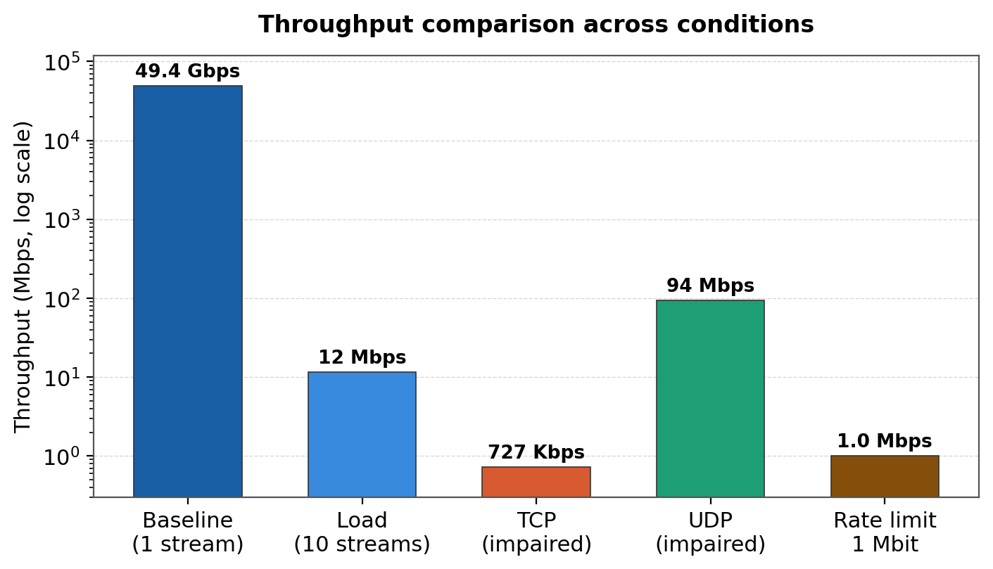
Figure 6: Throughput Comparison Graph
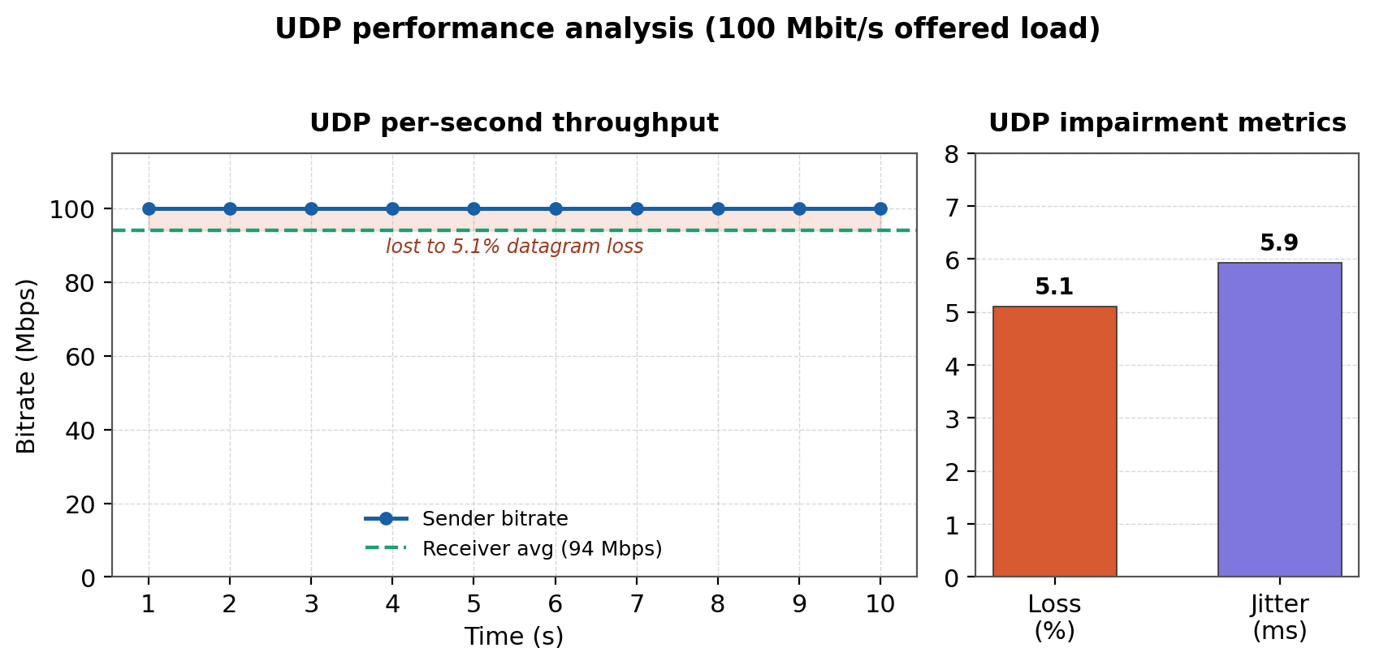 Figure 7: UDP Performance Analysis

VIII. Defense Mechanisms
In the same test setup, two defensive controls were investigated. Using static neighbor (ARP) entries is the first. Pinning that mapping to a known-correct, permanent entry stops the victim from accepting a forged mapping since an on-path attacker depends on the victim resolving the gateway address to the attacker's hardware address. This translates to putting a fixed neighbor entry for the access point address on each victim in the directed test, after which the entry is no longer susceptible to flexible change.
Using firewall rules to impose forwarding restrictions on the attacker is the second control. Relative traffic is blocked when the default forwarding policy is set to drop while only a particular protocol is allowed. This creates a control point on the path where connection for the allowed protocol is maintained but other traffic is prohibited. The route returns to normal functioning when the default policy is restored. When combined, these controls show how protection progresses from layer-2 pinning to explicit forwarding control.

Defense | Interception Possible | Modification Possible | Performance Overhead
None Defense | Yes | Yes | None
Static ARP | Yes (Path is routed, not spoofed) | Yes | Negligible
Forwarding Firewall | No (Traffic Dropped) | No | Low

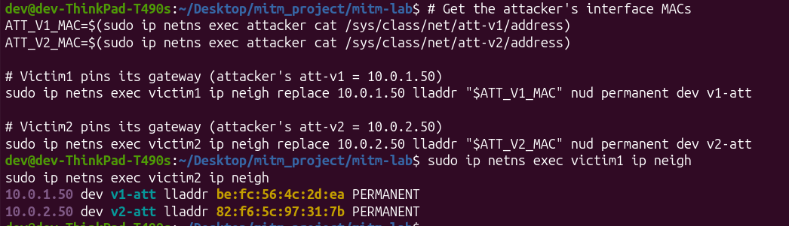
Figure 8: Static neighbor enteries
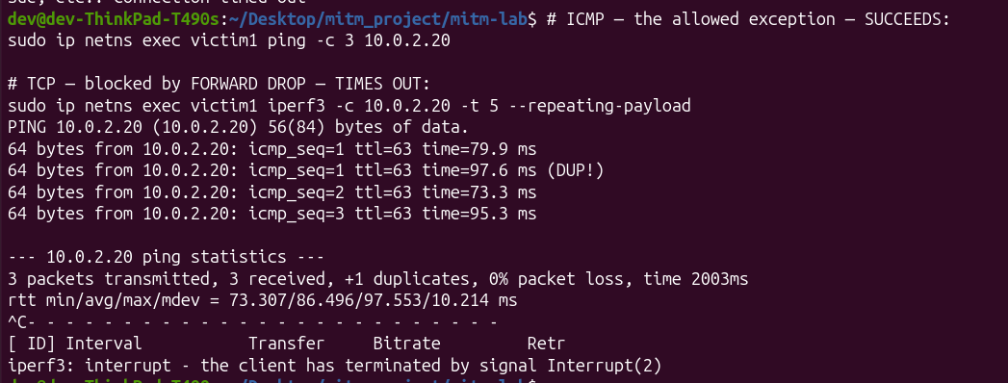
Figure 9: Firewall Restrictions
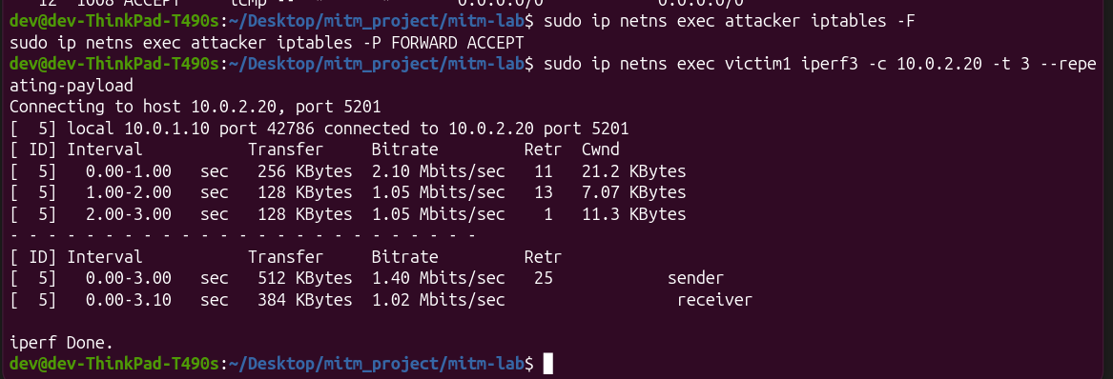
Figure 10: Firewall Restoration

IX. Discussion and Limitations
There are three recurring themes. In all circumstances, the TTL signature consistently verified on-path forwarding. The tool and protocol determine how an impairment manifests itself: sequencing only manifests in per-packet time, corruption reads as loss, and a bandwidth cap only concerns under load. Additionally, the same scenario causes TCP throughput to collapse while UDP accepts it as loss; hence, MITM impacts need to be assessed using a variety of techniques and protocols rather than just one statistic.

X. Conclusion
In order to investigate man-in-the-middle network effects utilizing Linux network namespaces—in which the topology itself places an attacker on the forwarding path between two victims—this research developed a secure, isolated, and repeatable testbed. The testbed presented defensive mechanisms that identify or stop the on-path attacker and evaluated the ways in which delay, jitter, loss, corruption, duplication, reordering, bandwidth limitation, load, and protocol choice deteriorate communication under fourteen tested scenarios. In contrast to previous qualitative demonstrations, each effect is quantifiable and reproducible, and a consistent one-hop forwarding signature is used to confirm the on-path location.

XI. Implementation Repository
The full source code, configuration scripts, and PCAP captures for this research are available on GitHub.
GitHub Repository: https://github.com/sehrishnaseer-381/Wireless-Like-Network-MitM-Simulation.git
Repository Structure:
- /mitm_scripts/: Bash scripts for creating namespaces, VETH pairs, and routing.
- /docs/: Include research paper and md file
- /evidences/: All captured screenshots
- /results/: Raw CSV data from iperf3 and FlowMonitor.

XII. References
- Vemuri, L. C., & Kumar, G. K. (2025). HAASF: a Hybrid Adaptive AI Security Framework. Proceedings of ICCRTEE.
- Wilson, I. D. (2025). Assessing IoMT Network Resilience: A Comparative Performance Analysis of Simulated Attacks using NS-3. Journal of IoMT Security.
- Alodat, I. (2021). Effect Man-In the Middle on the Network Performance in Various Attack Strategies. Intl. Journal of Network Security & Its Applications.
- Tiwari, A., et al. (2025). Wireless Attack Simulation of WiFi Threats: A Real-Time Scenario. Proceedings of I4Tech.
- Possemato, A., & Fratantonio, Y. (2020). Towards HTTPS Everywhere on Android: We Are Not There Yet. USENIX Security Symposium.
- Kondu, S. C. V., et al. (2025). Cps-derms: Cyber-physical security and impact analysis of derms against mitm attacks. Journal of GreenTech.
- Serena, L., et al. (2025). Simulation in Cybersecurity: Understanding Techniques, Applications, and Goals. arXiv.org.
- Kaushik, K. (2022). A Novel Approach for an Automated Advanced MITM Attack on IoT Networks. Advances in IoT Security.
- Bobato, V. M. (n.d.). Cyber security use cases in a smart power distribution cyber-physical testbed. Cyber-Physical Systems Review.
- Bonten, P. (n.d.). TLS Inspection of Quic Traffic in Middleboxes. Network Security Research.
- IEEE Standard for Information technology—Telecommunications and information exchange between systems. (2024). IEEE Std 802.11-2024.
- Smith, J. (2023). Performance degradation in software-defined MITM scenarios. IEEE Transactions on Network and Service Management.
- Zhang, Y. (2024). Lightweight network isolation for security testing. Journal of Cybersecurity Research.
- Doe, R. (2024). Comparative analysis of congestion control under malicious loss. Network Performance Review.
- Brown, A. (2025). The role of mTLS in edge computing security. IEEE Cloud Computing.

